Where to start to get help
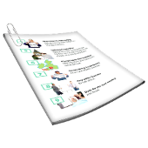 | This information is about where to go for help.  It has information on | Page
 | - Where to start to get help | 3
 | - Help in a crisis | 5
 | - Help when you are not in danger but very upset | 7
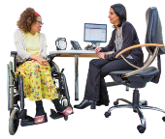 | - Seeing your GP | 8
 | - Seeing a counsellor | 10
 | - Where to find more information and support | 13

Where to start to get help
 | It is good to communicate with someone you trust if you want help with your mental health.
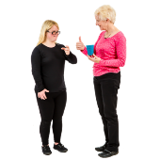 | To communicate is how you understand and share your feelings or information.
 | Mental health is about  - How you think  - How you feel
 | There are many people you might trust.  For more information about who you might trust go to https://www.idmhconnect.health/  someone-trust
 | It is OK if you do not want to communicate with these people.  You can get help from other places.
 | For more information about asking for help go to https://www.idmhconnect.health/  communicating-about-my-mental-health/ER

Help in a crisis
 | A crisis is when you are in danger or are very upset.  You are in danger if you could be hurt or injured.  It is important if you are in a crisis to go to the emergency department at the hospital.
Emergency departments are sometimes called ED.

You can also ask someone you trust to help you.
 | Call 000 for an ambulance or the police.
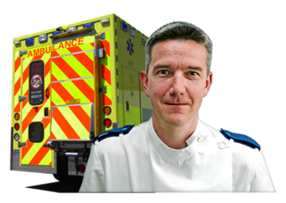 | Or go to an emergency department at a hospital.
 | You do not need an appointment to go to an emergency department.
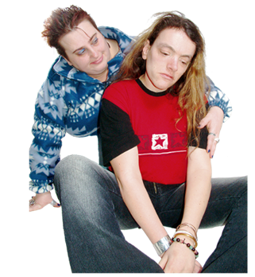 | An Emergency help card can keep you and others safe in a crisis.  An Emergency help card can support you and others to
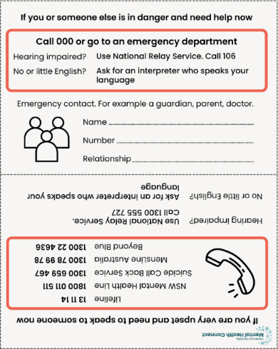 | - Know what to do in a crisis  - Know who to contact in a crisis  - Call phone lines that can support you in a crisis
   | For more information about  - The Emergency help card go to https://idmhconnect.health/emergency-help-template/ER  - Emergency help in a crisis go to https://www.idmhconnect.health/  emergency-help/ER
Help when you are not in danger but very upset

 | If you are not in danger but are very upset you can get support from a GP.
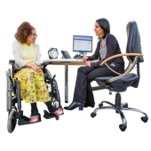 | A GP is the doctor that you see when you  - Are sick  - Need a health check
Your GP might suggest you communicate with a psychiatrist.

A psychiatrist is a doctor who helps you with your mental health.
 | You can also communicate with a psychologist.  A psychologist helps you with your mental health by talking with you.  To look for a psychologist go to www.psychology.org.au/Find-a-Psychologist
Seeing your GP
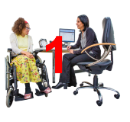 | A GP is usually the first health worker you see about your mental health.  Your GP can help you if you think you have a mental health problem.
Your GP may refer you to someone who specialises in mental health problems.

This might be a

- Psychologist

- Psychiatrist
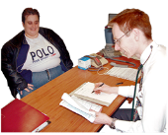 | A referral is when your GP says you should see a mental health worker if you need more help.
 | How to see a GP
 | If you have a GP you have seen before contact their office to make an appointment.  You can also ask someone to help you make an appointment.
 | You may also be able to make an appointment to see them online.
 | If you do not have a GP ask someone you trust if they know a good GP.
 | You can also ask your local chemist if they know a good GP.
 | To find a GP near you go to https://www.healthdirect.gov.au/  australian-health-services
 | For more information about how a GP can help you with your mental health go to https://www.idmhconnect.health/  mental-health-services-health-workers/ER
Seeing a counsellor
 | A counsellor is a health worker.  You can communicate with them about problems in your life.
 | You can communicate with them if  - Stressful things happen in your life  - You are worried about the future
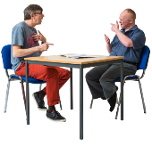 | Different mental health workers can offer counselling therapy.  Counselling therapy is when you chat with mental health workers about  - Issues in your life  - Ways you can fix these issues
 | How to find a counsellor
To find a counsellor you can

- Ask someone you trust if they know a good counsellor

- Ask where you work or study if they have counsellors

- Communicate with your GP
 | - Search for a counsellor through the Australian Counselling Association https://www.theaca.net.au/find-registered-counsellor.php
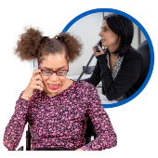 | You can contact SANE Australia.  SANE Australia can give you counselling.  SANE Australias counsellors will  - Listen to what is worrying you  - Give ideas for what you can do next
 | Contact SANE Australias counsellors 10 am to 10 pm Monday to Friday.  - Call 1800 187 263  - Go to https://www.sane.org/get-support/drop-in-service  - Email helpline@sane.org
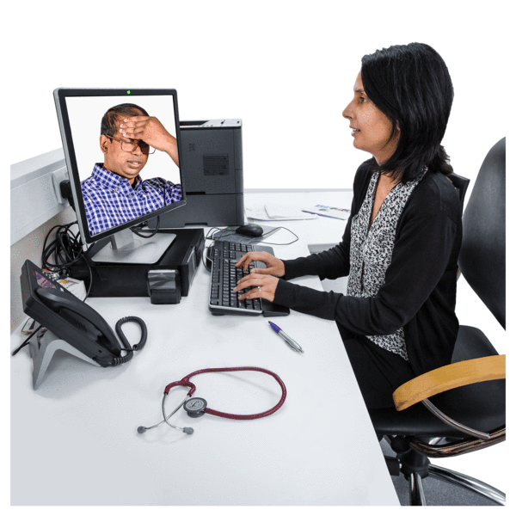 | SANE has a new Guided Service.  This service gives free online and telehealth services and support to people  - 18 years or older  - With complex mental health needs  Support is available for people with intellectual disability or autism.
 | You may have to pay to see a counsellor.  It is good to communicate with someone if you are worried about paying.
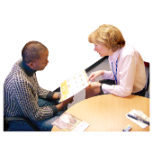 | You might chat about payment options with  - Your GP  - NDIS Support Coordinator if you have an NDIS plan
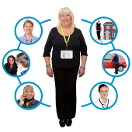 | A support coordinator is a person who helps plan and organise  - Your care  - Other services you get
Where to find more information and support
 | There is information online about how to  - Have good mental health  - Cope with mental health problems
 | Online tools and information
 | Council for Intellectual Disability Tips to have good mental health https://cid.org.au/resource/tips-help-mental-health/
Healthy Mind program can help with your mental health https://www.healthymind.org.au/

Healthy Mind was made for people with intellectual disability.

 | THIS WAY UP has information to help you in tough times https://thiswayup.org.au/coping-and-resilience-tools/  THIS WAY UP has information in other languages https://thiswayup.org.au/coping-and-resilience-tools/multilingual-resources/
 | The Black Dog Institute has tools to support mental health  https://www.blackdoginstitute.org.au/resources-support/digital-tools-apps/  Not all of these tools are in Easy Read but they may still be useful.
 | Beyond Blue has information about mental health https://www.beyondblue.org.au/  Headspace for young people has information about mental health https://headspace.org.au/
 | Organisations you can contact
 | Some organisations can give advice on where you can get help over the phone and online.
Lifeline Australia

Call on 13 11 14 any time of the day.

Text 0477 13 11 14 12 noon to 6am.

Chat online at https://www.lifeline.org.au/crisis-chat/ 12 noon to 6 am.
Beyond Blue

Call on 1300 22 4636 at any time of the day.

Chat online at https://www.beyondblue.org.au/support-service/chat 1 pm to 12 midnight.
 | Mens Line Australia  Call on 1300 78 99 78 at any time on any day.  Chat online at https://mensline.org.au/phone-and-online-counselling/ at any time on any day.
 | NSW Mental Health Line  If you need to speak with a mental health worker you can ring the NSW Mental Health Line on 1800 011 511 any time on any day.
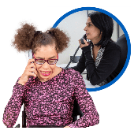 | The mental health worker may  - Refer you to the local mental health team  or  - Give you information about other services that can help you
 | Way Ahead Mental Health Information Service  Call on 1300 794 991 Monday to Friday from 9 am to 5 pm.
 | Tip  Some websites can be tricky to use.  You can ask someone to help you use websites and find information.
 | Many websites have accessibility features.  Accessibility features are features that can help you use the website.  For example you can change  - The size of the writing  - Have the text read out
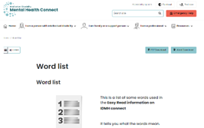 | There are some tricky words in this Easy Read sheet.  For more information about these words go to  https://www.idmhconnect.health/word-list


 | Who wrote this Easy Read  Janelle Weise, Claire Eagleson, Jenna Zhao, Tahli Hind, Dominique Abagi and Julian Trollor.
 | Where these people work  Department of Developmental Disability Neuropsychiatry UNSW Sydney.  Also known as 3DN.  For more information about who wrote this Easy Read go to https://idmhconnect.health/who-wrote-easy-read
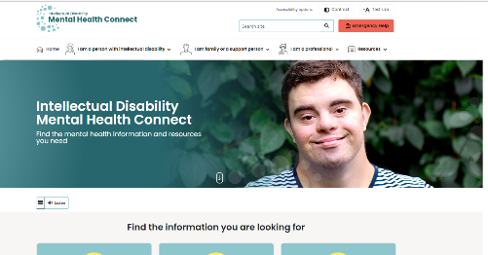   | The Council for Intellectual Disability reviewed this Easy Read sheet.  The information in this Easy Read sheet is from the https://idmhconnect.health/ website
 | For information on how to support people to use Easy Read go to https://www.3dn.unsw.edu.au/ professionals_toolkit  © Department of Developmental Disability Neuropsychiatry UNSW Sydney 27.01.2023 v2  No changes can be made without asking the people who wrote this sheet.

