Tips for good mental health
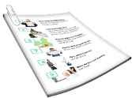 | This information is about tips for good health.  It has information on | Page
 | - Ideas for staying healthy and feeling well. | 2
 | - Ways to have good mental wellbeing and feel happy | 7

Ideas for staying healthy and feeling well
 | Below are some ideas for how to stay healthy and feel well.
 | All of these ideas can help you have good mental wellbeing.
Good mental wellbeing means you

- Are generally happy with life

- Can cope with stress

 | - Can do activities you want to do
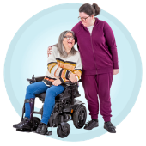 | - Have friends to support you
 | To cope means you can deal with difficult things.
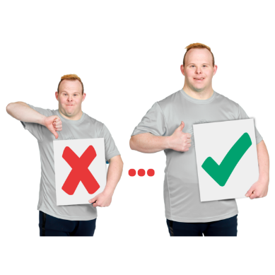 | The ideas below can also help you to get better if you have had mental health problems in the past.
To stay healthy and feel well you might build a strong social network.

A social network is all the people around you who can support you.
Your social network will have people you trust.

There are many people you might trust.

For more information about who you might trust go to https://www.idmhconnect.health/
someone-trust
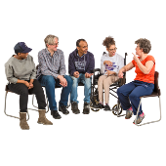 | To stay healthy and feel well you might continue with  - Community activities  - Support groups  A support group is a small group of people you meet with to communicate about mental health.
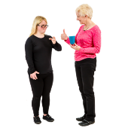 | To communicate is how you understand and share your feelings or information.
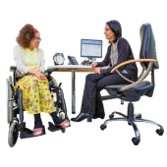 | You might also  - Have regular check-ups with your doctor  - Communicate with your doctor about managing your health issues
If it helps you might keep a journal.

Sometimes a journal is called a feelings diary.

A feelings diary is a place where you can note down your thoughts and feelings.

A journal can help you

- Think about your experiences

- Plan ahead for any tough times
For more information about how you can use a journal or feelings diary go to https://www.idmhconnect.health/
communicating-about-my-mental-health/ER

To stay healthy and feel well it is important to ask for help early if you start to notice a change in how you are feeling.

You can communicate with someone you trust.

Ways to have good mental wellbeing and feel happy
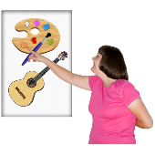 | Do activities  You can stay healthy and feel well by doing activities.  You can do activities
 | - Alone
 | You can do activities with other people
 | Doing activities can make you feel like you have achieved things.
 | Doing activities helps you not focus on negative feelings or things going on around you.
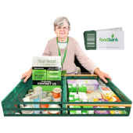 | Doing activities can also give you a sense of meaning.  A sense of meaning gives us a feeling of  - Being part of something  - That life is useful and valuable
 | Below are some examples of activities you can do.
You can go to social events that interest you.

There are many community groups that offer social outings and activities.
For more information about community groups go to

- Disability Trust https://www.disabilitytrust.org.
au/services-and-support/
making-friends-social-groups-and-outings

- Gig Buddies https://www.gigbuddiessydney.
org/
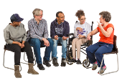 | You can also join a group where you can communicate to others.  For example One Door Mental Health support groups.  For more information about One Door Mental Health support groups go to https://www.onedoor.org.au/
Stay in contact with your family and friends if that will help you.

To stay in contact you might

- Call your family

- Visit your family

- Ask them to visit you
Other examples of activities you can do are

- Use relaxation techniques.

To help you relax you can use apps such as Smiling Mind.

For more information about Smiling mind go to https://www.smilingmind.com.au/
smiling-mind-app
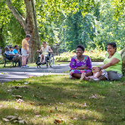 | - Exercise and be in nature.
Some other activities include

- Hobbies

- Games

- Activities you enjoy
 | Finding healthy foods you enjoy to have a balanced diet.
You can spend time on hobbies.

You can take trips away.

There are groups that can help you with trips.

For example Trusted Travel.

For more information about Trusted Travel go to https://www.trustedtravel.org.au/

Have a sense of meaning

People who have a sense of meaning

- Are better able to cope in difficult times

- Have better wellbeing
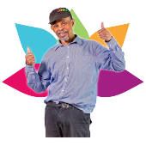 | Below are some examples of things you can do to have a sense of meaning.
You can get involved in community projects.

For example beach clean-up day.

 | You can find a job.
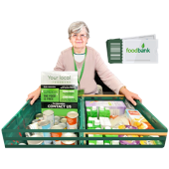 | You can volunteer if appropriate.  When you volunteer you give your time to help an organisation.
For more information about who you can volunteer with go to

- Disability Gateway https://www.disabilitygateway.
gov.au/employment

- The Centre for Volunteering https://www.volunteering.com.au/join-us/inclusive-volunteering-pathways-to-employment-program/
You can advocate for yourself or others.

To advocate is you or someone else doing things so that your rights and needs are met.
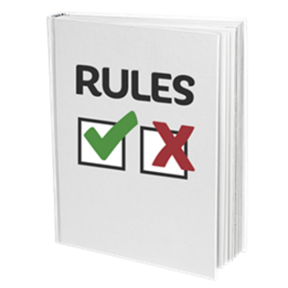 | Rights are rules about how everybody should be treated fairly.  A right is something everyone has.
For more information about how you can advocate for yourself or others go to

https://www.idmhconnect.health/
about-advocacy/ER
 | You can also do things that can increase your skills.
You can take note of

- Your strengths and when you do things that use them

- Things that have gone well
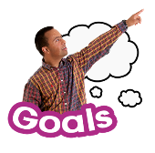 | To set goals can help you to have a sense of meaning.

All of the above suggested activities can help you to have positive emotions.

Positive emotions

- Make you feel good

- Benefit different areas of your life
 | What people find positive is different for everybody.
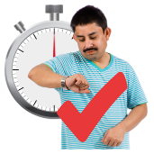 | It is important to take time to find out what is positive for you.
You can find time to be relaxed.

For example you can listen to music.

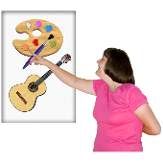 | You can find a place to keep things that make you happy that you can go to often.
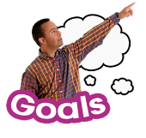 | You can set goals for the future.
 | You can take time to reflect when things go well.
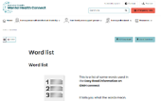 | There are some tricky words in this Easy Read sheet.  For more information about these words go to  https://www.idmhconnect.health/word-list

Who wrote this Easy Read

Janelle Weise, Claire Eagleson, Jenna Zhao, Tahli Hind, Dominique Abagi and Julian Trollor.

Where these people work

Department of Developmental Disability Neuropsychiatry UNSW Sydney.

Also known as 3DN.

For more information about who wrote this Easy Read go to https://idmhconnect.health/who-wrote-easy-read
 | The Council for Intellectual Disability reviewed this Easy Read sheet.
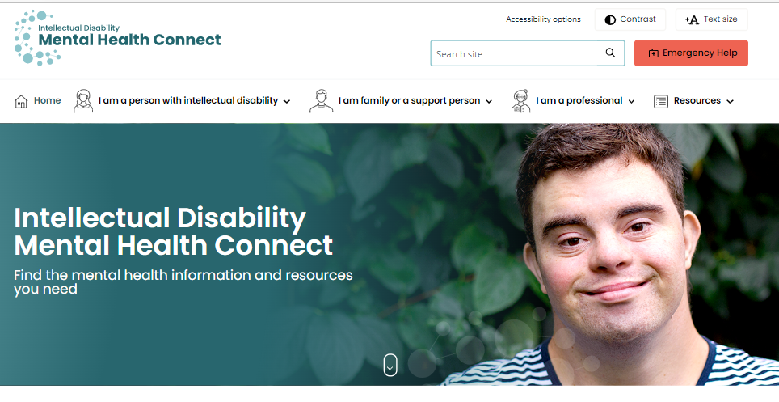 | The information in this Easy Read sheet is from the https://idmhconnect.health/ website
For information on how to support people to use Easy Read go to https://www.3dn.unsw.edu.au/ professionals_toolkit

© Department of Developmental Disability Neuropsychiatry UNSW Sydney 27.01.2023 v2

No changes can be made without asking the people who wrote this sheet.

