Supports for various groups
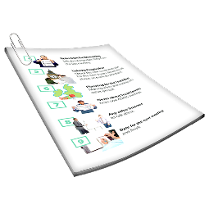 | This information is about people and services that can support people with intellectual disability from different groups.  It has information for
 | - First Nations peoples
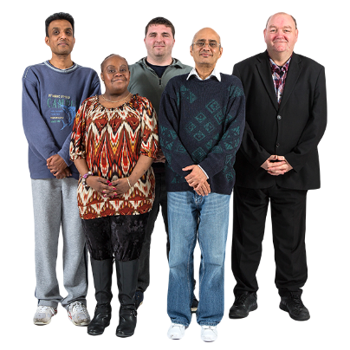 | - Culturally and linguistically diverse people
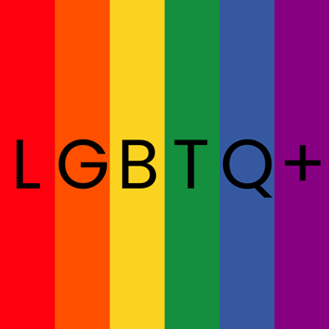 | - LGBTQ+ people
 | - People living in rural and remote areas
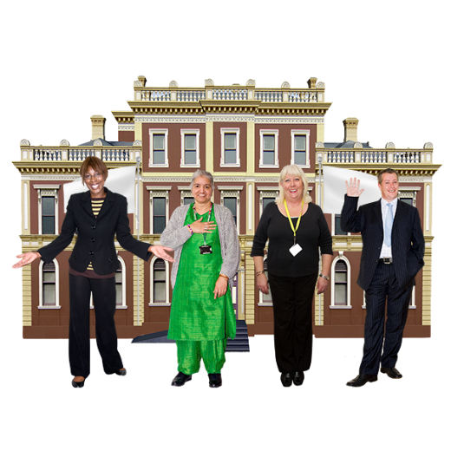 | - People in contact with the criminal justice system
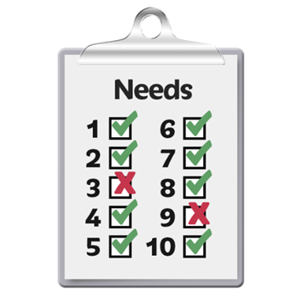 | - People with many support needs
 | - People who have had trauma
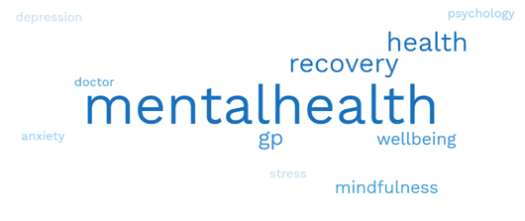 | There is a lot of information.  Some words can be hard to understand.
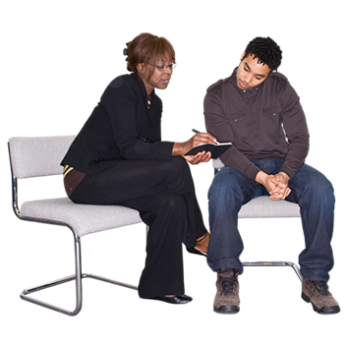 | You can ask someone to read this information with you.
First Nations peoples
 | Below are services and supports for First Nations peoples.
 | For more information about First Nations peoples visit https://www.idmhconnect.health/  first-nations-peoples/ER
 | Translation and interpreter services
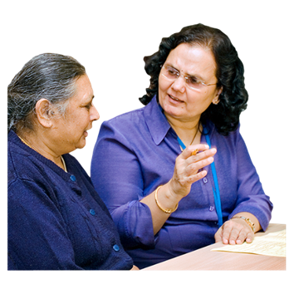 | An interpreter is a person who changes words from your language to a language someone else understands.
 | The Translating and Interpreting Service provides onsite and on phone interpreting.  To contact the service  - Call 131 450  - Visit https://www.tisnational.gov.au/  Help-using-TIS-National-services/Contact-TIS-National
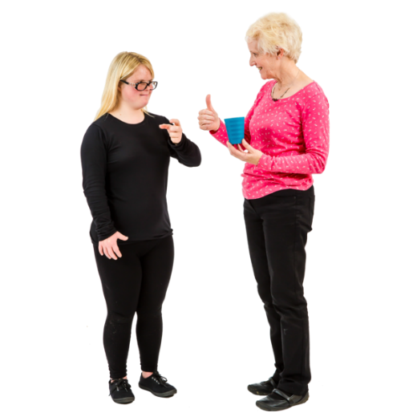 | The National Interpreting and Communication Services provides interpretation for some of the different First Nations sign languages.  The hours can be paid under NDIS interpreting hours.  For more information visit https://www.nicss.org.au/aboriginal-and-torres-strait-islander.html
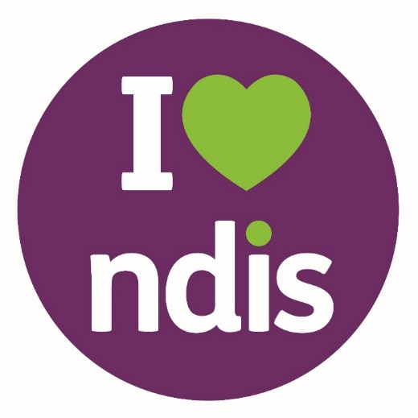 | NDIS is short for National Disability Insurance Scheme.
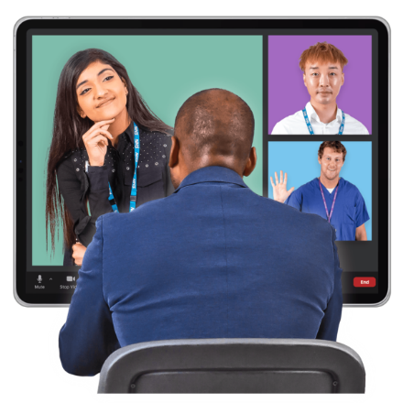 | 2M Language Services can provide interpreters for some of the First Nations languages for a fee.  For more information about the service visit https://www.2m.com.au/interpreting-services/indigenous-language-interpreting/

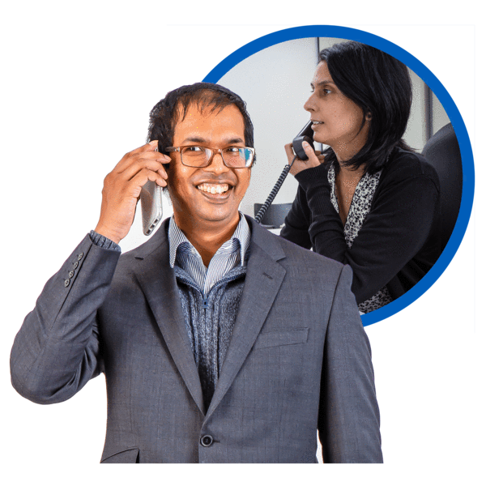 | Lifeline Australia provides crisis support in different languages.  You can ask to speak to someone in your language.  A crisis is when you are in danger or are very upset.  To contact Lifeline  - Call 13 11 14  - Visit https://www.lifeline.org.au/  crisis-chat/

 | Mental health supports
 | Mental health is about  - How you think  - How you feel
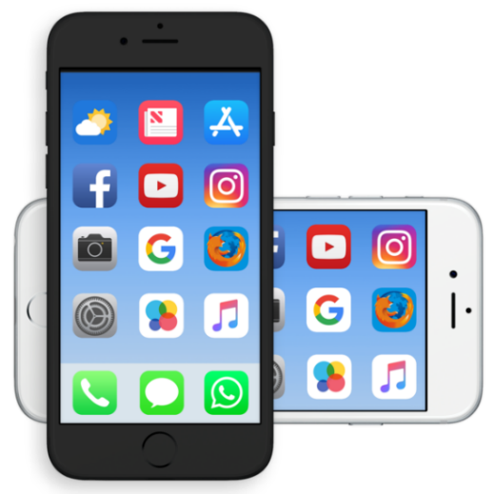 | iBobbly is an app designed for First Nations peoples to support their own mental health.  For more information visit https://www.blackdoginstitute.org.au/ resources-support/digital-tools-apps/ibobbly/
 | WellMob is an online tool for First Nations peoples to support their own mental health.  For more information about WellMob visit https://wellmob.org.au/
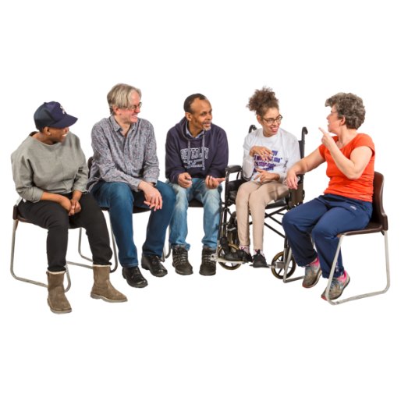 | Proppa Deadly is a talk show where First Nations people tell their stories about mental health problems.  For more information about Proppa Deadly visit https://triplea.org.au/listen/  programs/lets-talk/proppa-deadly-  napsia-vin-thal/
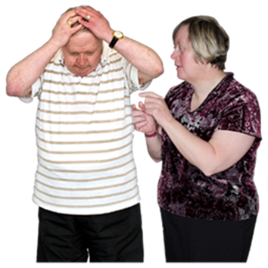 | A mental health problem is when your feelings start to worry you.
Trauma and Grief Network has helpful information and tips about dealing with trauma and grief for First Nations peoples.

Trauma is when something has happened to you that made you very frightened or upset.

 | Grief is when you have lots of different feelings when someone dies.
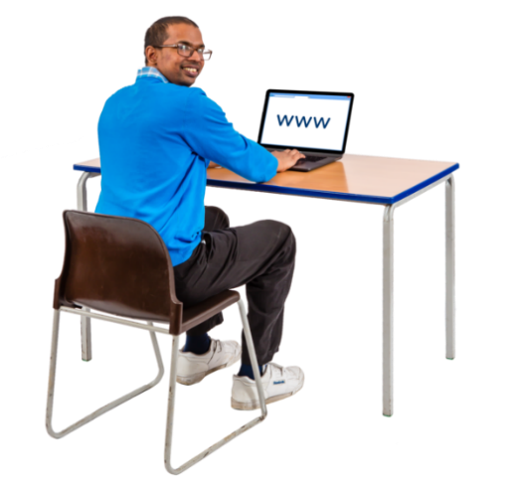 | For more information about the Trauma and Grief Network visit https://tgn.anu.edu.au/resource/  indigenous/
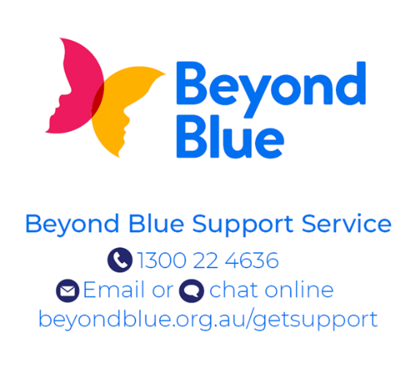 | Beyond Blue gives information about mental health problems for First Nations peoples.  To see the information visit https://www.beyondblue.org.au/  who-does-it-affect/aboriginal-and-  torres-strait-islander-people
 | Beyond Blue also provides information about dealing with discrimination because of your First Nations background.  For more information visit  https://www.beyondblue.org.au/who-does-it-affect/the-invisible-discriminator
 | Other services and supports
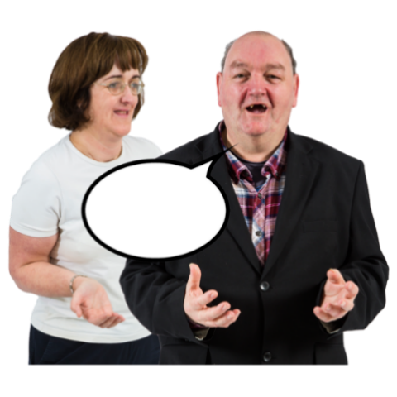 | First Peoples Disability Network provides advocacy and support for First Nations peoples with disability.  Advocacy is having your voice heard so your rights and needs are met.  You can have needs in many areas of your life.
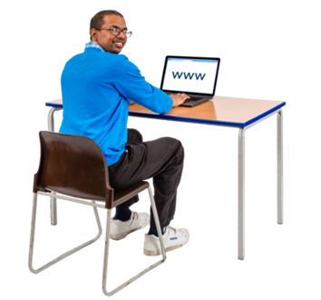 | For more information about the First Peoples Disability Network visit https://fpdn.org.au/lets-have-a-yarn-about-advocacy/
 | National Indigenous Postvention Service provides support for First Nations people and communities affected by suicide.  To contact this service call  1800 805 801.
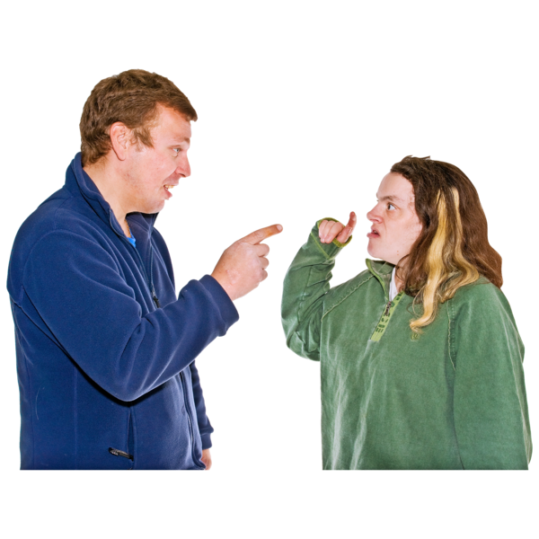 | Aboriginal and Torres Strait Islander mediation provides free mediation conflict management services.  Mediation is when a person comes to support people after they have big arguments or fights.
For more information about the mediation services visit https://www.cjc.justice.nsw.gov.au/Pages/ cjc _whytry_mediation/com_justice_
mediation_atsi.aspx

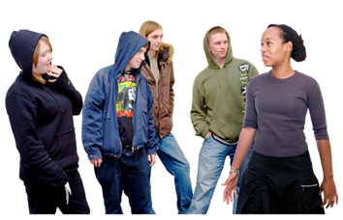 | All Together Now provides information for people who want to report racism.  Racism is when people discriminate against you because of your culture or background.  Discrimination is when someone is treated badly because of something about them they cannot control.
For information about All Together Now visit https://alltogethernow.org.au/
racism/reporting-racism/

 | Wuuwi Gambling can provide counselling services for First Nations peoples with gambling issues.  Gambling is when you play games for the chance to win money.
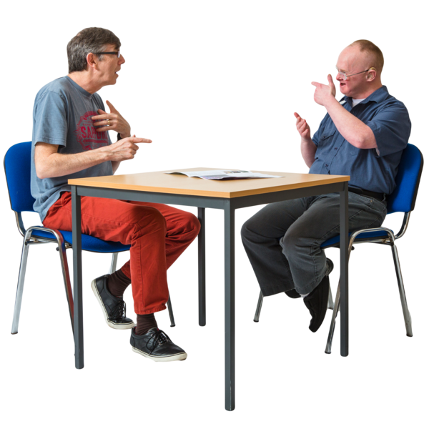 | Counselling therapy is when you chat with mental health workers about  - Issues in your life  - Ways you can fix these issues
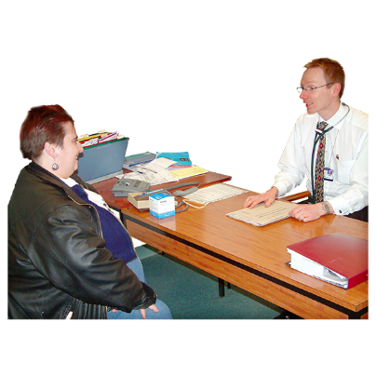 | Mental health workers are people who work to help you with your mental health.
For more information about Wuuwi Gambling visit https://aboriginalsafegambling.
com.au/

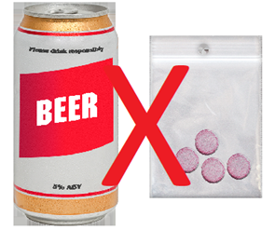 | Your Room provides information on services that support First Nations peoples to reduce the harm caused by alcohol and drugs.  They also provide culturally safe phone counselling and referral.
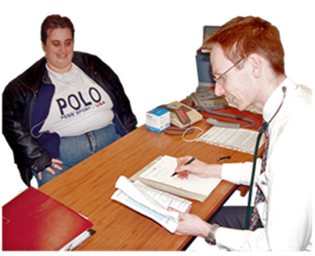 | A referral is when someone suggests you see a worker who can support you.
For more information about Your Room visit https://yourroom.health.nsw.gov.au/
Pages/home.aspx

 | Search tools for health services and supports
 | Ask Izzy can help you search for the right services and supports for you.  For more information about Ask Izzy visit https://askizzy.org.au/
 | Australian Indigenous HealthInfoNet has a search tool to find First Nations health workers and health practitioners near you.  To use the search tool visit https://healthinfonet.ecu.edu.au/key-resources/health-professionals/health-workers/map-of-aboriginal-and-islander-healthmedical-services/
 | Aboriginal Health and Medical Research Council provides a list of First Nations health services across NSW.  For more information visit https://www.ahmrc.org.au/member-services/
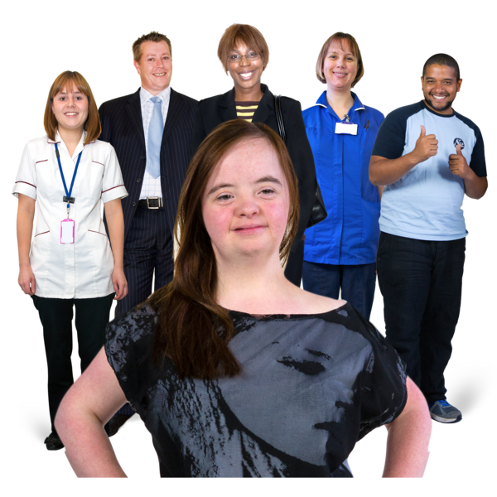 | The National Aboriginal Community Controlled Health Organisation provides a list of Aboriginal community health centres in NSW.  For more information about the community health centres visit https://www.naccho.org.au/naccho-members/

Culturally and linguistically diverse people
Culturally and linguistically diverse is used to describe people who identify as belonging in some way to a non-Australian culture.

Culturally and linguistically diverse is known as CALD for short.

For more information about CALD people visit https://www.idmhconnect.health/
culturally-and-linguistically/ER
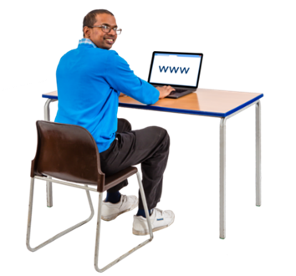 | Below are services and supports for CALD people.

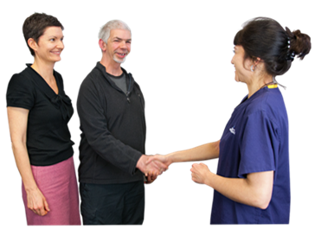 | The Multicultural Disability Advocacy Association provides advocacy services for people with disability from CALD communities.
 | The Multicultural Disability Advocacy Association also supports people with NDIS appeals and reviews.  An appeal is when you ask someone to have another meeting.
 | For more information about the Multicultural Disability Advocacy Association visit http://mdaa.org.au/services/

The Ethnic Community Services Co-operative provides
- NDIS services and information

 | - Advocacy
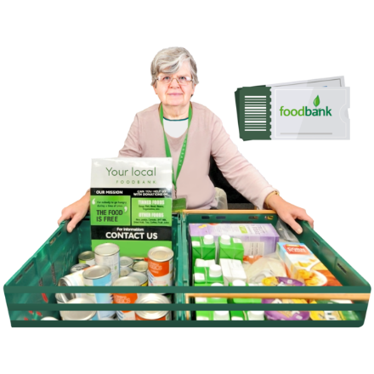 | - Volunteer projects for people with disability  When you volunteer you give your time to help someone.  You do not get paid for your help.
 | They also provide  - Support for people looking for work experience and paid work
 | For more information about the Ethnic Community Services Co-operative visit https://ecsc.org.au/
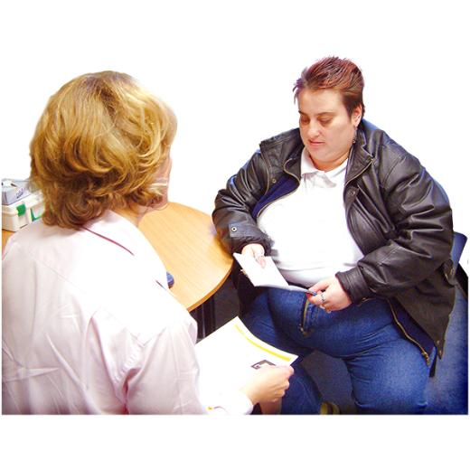 | Open Minds has support services for people from CALD communities with mental health problems.  For more information about Open Minds visit https://www.openminds.org.au/  services/supporting-culturally-and-linguistically-diverse-people-cald
Action on Disability within Ethnic Communities has services and information including
- Advocacy support

 | - Videos about the NDIS in different languages
- Social support groups

A support group is a small group of people you meet with to communicate about mental health.
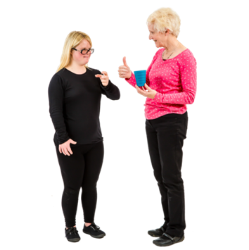 | To communicate is how you understand and share your feelings or information.
 | For more information about Action on Disability within Ethnic Communities visit https://adec.org.au/

Kin provides advocacy support for people with disability from CALD communities.

For more information about Kin visit https://kinadvocacy.org.au/

The Federation of Ethnic Communities Councils of Australia has a program that supports people from CALD backgrounds to access the NDIS.

For more information about the program visit https://fecca.org.au/
communityconnectors/

 | Translation and interpreter services
Translating and Interpreting Service provide onsite and on phone interpreting.

To contact the service
- Call 131 450

- Visit https://www.tisnational.gov.au/
Help-using-TIS-National-services/Contact-TIS-National

 | NSW Health Care Interpreting Services have free and confidential interpreters when you go to hospital for your care.  Confidentiality means that information about you must not be shared with others unless you say that it is OK to share.
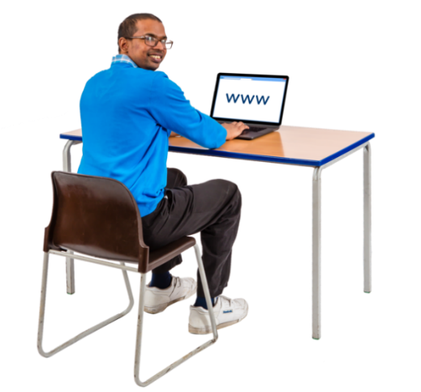 | For more information about the NSW Health Care Interpreting Services visit https://www.health.nsw.gov.au/  multicultural/Pages/Health-Care-Interpreting-and-Translating-Services.aspx
Lifeline Australia provides crisis support in different languages.

You can ask to speak to someone in your language.

To contact Lifeline
- Call 13 11 14

- Visit https://www.lifeline.org.au/

 | Translated information for people from CALD communities
 | Below is a list of websites with information in different languages.  The information from the websites below is not in Easy Read but can still be helpful.  If you want you can ask someone to support you to read them.
Embrace Multicultural Mental Health provides mental health information in different languages.

For more information visit https://embracementalhealth.org.au/

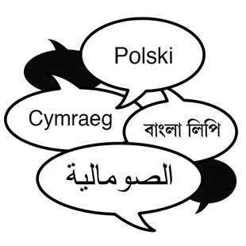 | The Multilingual Disability Hub has information on disability and the NDIS in different languages.  To see the information visit https://www.cesphn.org.au/images/  MDH_General.pdf
 | Amparo Advocacy Inc has information on the rights of people with an NDIS plan.  Rights are rules about how everybody should be treated fairly.  A right is something everyone has.  To read the information visit https://www.amparo.org.au/ndis-and-participants-rights/
 | Your NDIS plan says what supports you need.
The Cerebral Palsy Alliance has some information translated into different languages.

To read the information visit https://cerebralpalsy.org.au/
resources-in-other-languages/

Centrelink information about the Disability Support Pension has been translated into different languages.

To read the information visit https://www.servicesaustralia.gov.au/
disability-support-pension-translation

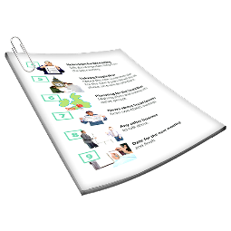 | UnitingSA has factsheets to help CALD communities to access the NDIS.  To read the factsheets visit https://unitingsa.com.au/community-services/ndis-disability-support/
The Transcultural Mental Health Centre has mental health information in different languages.

To read the information visit https://www.dhi.health.nsw.gov.au/
transcultural-mental-health-centre-tmhc/resources/in-your-language

LGBTQ+ people
 | LGBTQ+ stands for lesbian, gay, bisexual, transgender and questioning.
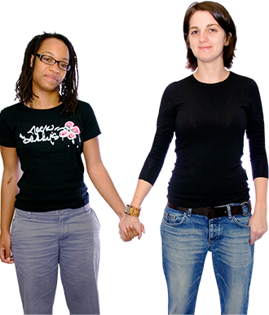 | Lesbian means women who are attracted to other women.
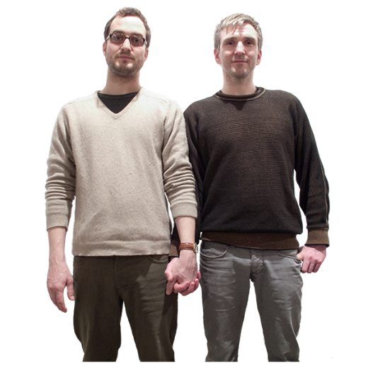 | Gay means men who are attracted to other men.
 | Bisexual means people who are attracted to both men and women.
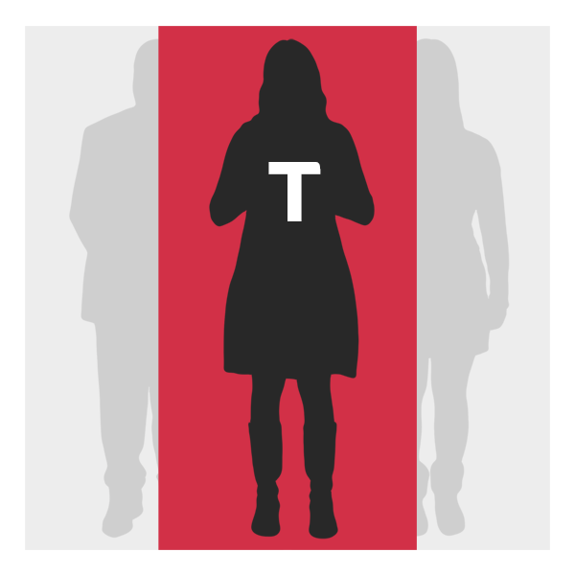 | Transgender refers to people who are now a different gender to the one that they were given when they were born.
 | Questioning is if you feel that you might not be heterosexual but you are not sure.
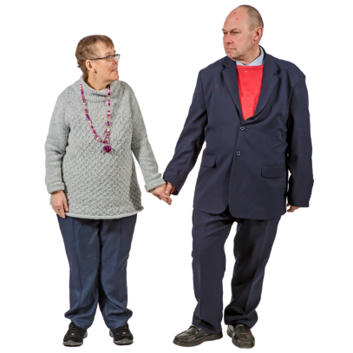 | A heterosexual person is  - A woman who is attracted to men  or  - A man who is attracted to women
For more information about LGBTQ+ people visit https://www.idmhconnect.health/
lgbtq-people/ER

 | Below are services and supports for LGBTQ+ people.
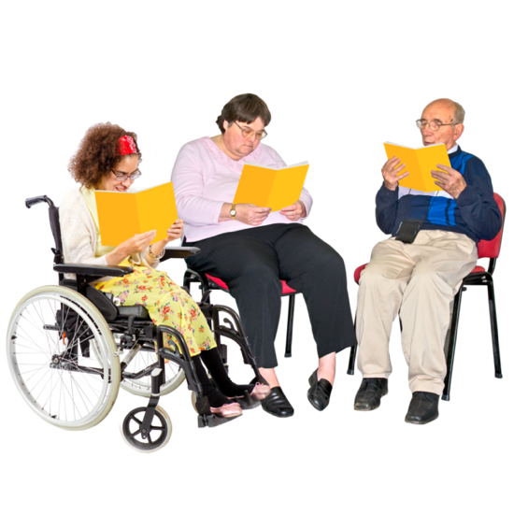 | Family Planning NSW has a Sexuality and Disability Service.  The sessions are included in your NDIS plan.  For more information visit https://www.fpnsw.org.au/factsheets/  individuals/disability/sexuality-and-disability-service
 | Family Planning NSW also has Easy Read information about  - Relationships  - Sexual health  - Sexual identity  To read the information visit https://www.fpnsw.org.au/factsheets/  individuals/disability/all-about-sex
 | CHANGE has an Easy Read guide on being LGBTQ+.  CHANGE is a group that is not in Australia but the information might still be helpful.  For more information visit https://www.changepeople.org/our-work/lgbtq-an-easy-read-guide
Twenty10 helps people in NSW between 12 and 25 years old who identify as LGBTQ+.

For more information about Twenty10 visit https://www.twenty10.org.au/

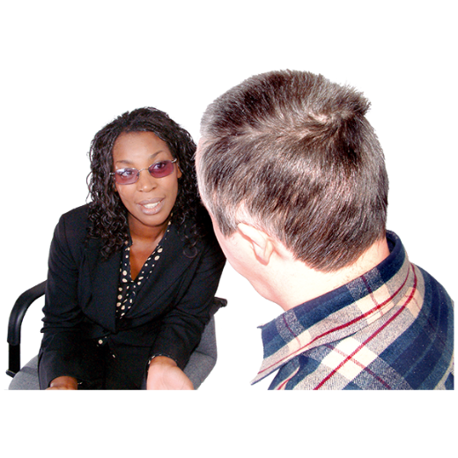 | Twenty10 has services for everyone, not just people with intellectual disability.  Twenty10 provides  - Counselling
 | - Mental health support
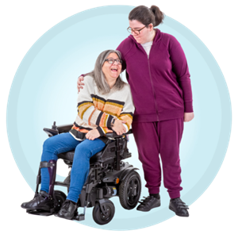 | - Support for social skills
QLife is a chatline that provides free LGBTQ+ peer support and referrals.

You can
- Call QLife on 1800 184 527 between 3pm and 12am midnight every day

- Chat to QLife online https://qlife.org.au/

Relationships and Private Stuff has counselling and education to support you.

Their services can be included in your NDIS plan.

For more information about Relationships and Private Stuff visit https://www.relationshipsand
privatestuff.com/

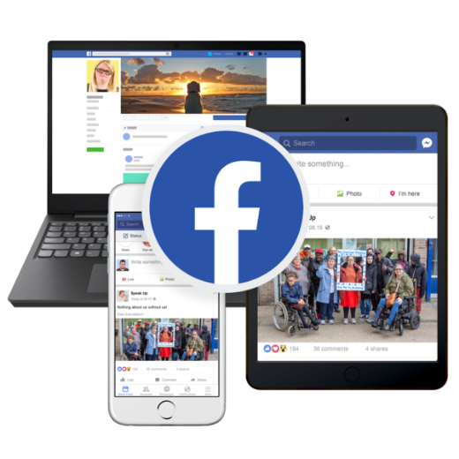 | Sydney Queer and Disability Community is a group on Facebook that raises awareness for LGBTQ+ people with disability.  For more information about the community group visit https://www.facebook.com/  queeranddisabled
Rainbow Rights and Advocacy is a self-advocacy group.

A self-advocate is someone who speaks up for themselves.

Rainbow Rights and Advocacy is run by and for LGBTQ+ people with intellectual disability.

For more information visit https://rainbowrights.com.au/

People living in rural and remote areas
People who live in the country do not have as many health and disability services as people who live in the city.

Country areas are sometimes called rural and remote areas.

For more information about people living in rural and remote areas visit https://www.idmhconnect.health/
people-living-rural-and-remote-areas/
ER

 | Below are service and supports for people who live in rural and remote communities.
 | Specialist Intellectual Disability Health Teams have mental health workers who know how to work with people with intellectual disability.
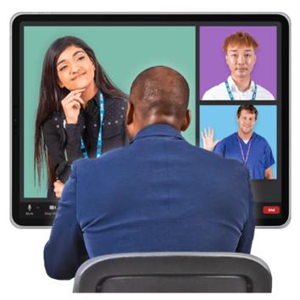 | The mental health workers can have appointments with you using teleconferencing.  Teleconferencing allows you to see and communicate with people online.  You can use programs like Zoom to teleconference.
 | The mental health workers may also come to your area.
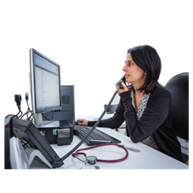 | Specialist Intellectual Disability Health Teams can give advice to your doctor or mental health worker.
For more information about specialist services visit
https://idmhconnect.health/mental-health-services-services/ER

People in contact with the criminal justice system
A person who has come into contact with the criminal justice system is someone who needs to communicate with or go to the
- Police

- Courts

- Prisons
 | The courts are where people decide if someone has broken the law.
 | Prisons are places where some people stay if they have broken the law.
For more information about the criminal justice system visit https://www.idmhconnect.health/
people-contact-justice-system/ER

 | Below are services and supports for people in contact with the criminal justice system.
 | The Justice Advocacy Service is a free advocacy service.  For more information about the service visit https://idrs.org.au/jas/
 | You can get a justice advocate to support you.  A justice advocate supports and assists people who are involved in the criminal justice system.
 | A justice advocate who works at a Justice Advocacy Service is free.
 | They can organise a support person for you.  A support person supports people with intellectual disability to  - Have all their rights met  - Fully participate in the processes of the criminal justice system
 | The justice advocate or support person can support you to  - Know what to expect will happen
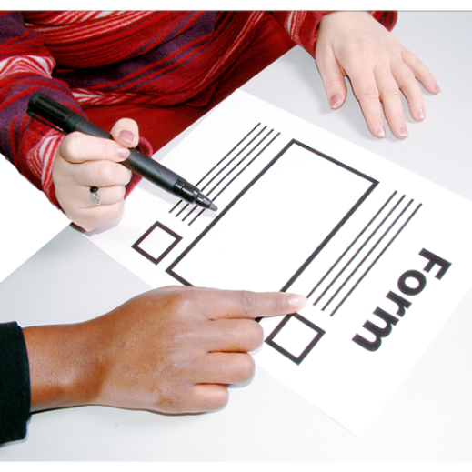 | - Fill in forms
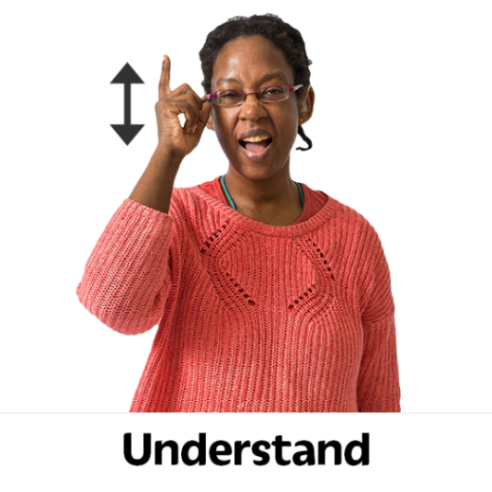 | - Understand how you should be treated
 | - Stay calm
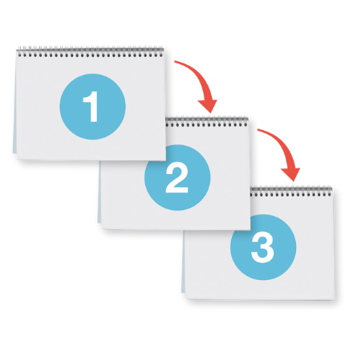 | - Understand what has happened  - Understand what will happen next
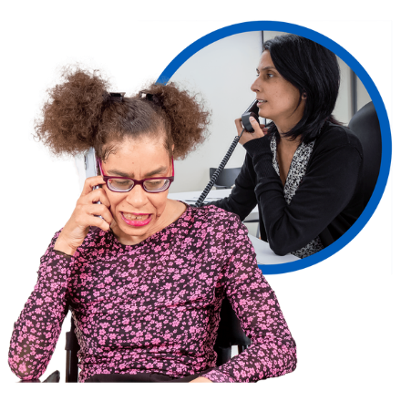 | The Community Restorative Centre has a free telephone information and referral service.  Call them on (02) 9288 8700 between 9am and 5pm.
 | The Community Restorative Centre also has services and programs that support people who have left prison.
 | For more information about the Community Restorative Centre visit https://www.crcnsw.org.au/get-help/

People with many support needs
People with intellectual disability can have many support needs.

Support needs means you need support with different things in your life.

Support needs are sometimes called complex needs.

For more information about multiple needs visit https://www.idmhconnect.health/
people-multiple-needs/ER

 | Below are services and supports for people with multiple needs.
Specialist Intellectual Disability Health Teams know how to work with people with intellectual disability.

They can work with your doctor or health workers to help support you.

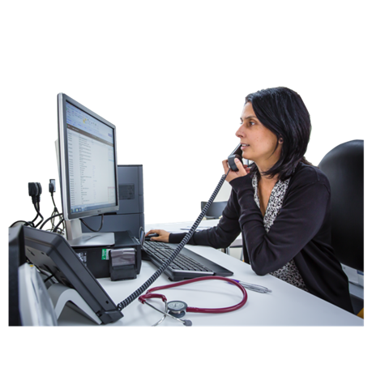 | The Statewide Intellectual Disability Mental Health Hubs know how to work with people with intellectual disability.  They can work with your doctor to help support you.
 | You can let your doctor know about the Hubs.
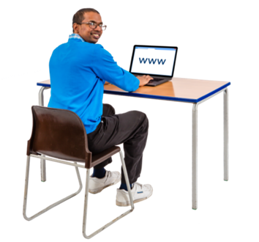 | For more information about the Hubs visit https://www.health.nsw.gov.au/  mentalhealth/Pages/intellectual-  disability-mental-health-hubs.aspx
The NSW Developmental Disability Health Unit can work with your GP to support your health problems.

For more information about the unit visit https://cds.org.au/clinics-services/royal-rehab-clinic-ddhu/

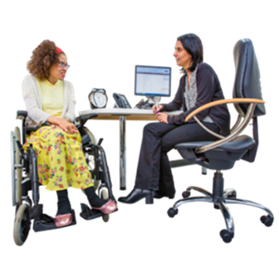 | A GP is the doctor you see when  - You are sick  - You need a health check
 | The Admission2Discharge Together Folder can keep together your health information.  The folder can make it easier for you if you need to go to hospital.  You can take the folder with you to hospital.  For more information about the folder visit http://a2d.healthcare/
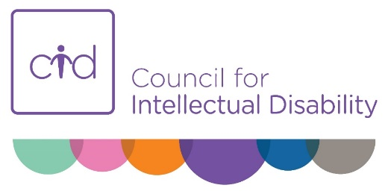 | The Council for Intellectual Disability has a My Health Matters folder.  For more information about the folder visit https://cid.org.au/resource/my-health-matters-folder/

People who have had trauma
People with intellectual disability can experience many situations or events that can cause them trauma.

Trauma is when something has happened to you that made you very frightened or very upset.

For more information about trauma visit https://www.idmhconnect.health/
people-who-have-had-trauma/ER

 | Below are services and supports for people who have experienced trauma.
Call the Disability Abuse and Neglect Hotline if you want to tell someone about
- Abuse

- Bullying

- Neglect

You can call the Disability Abuse and Neglect Hotline on 1800 880 052.

It is free to call them.

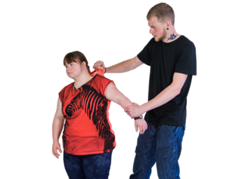 | Abuse is when someone says or does something to hurt you or make you feel bad.
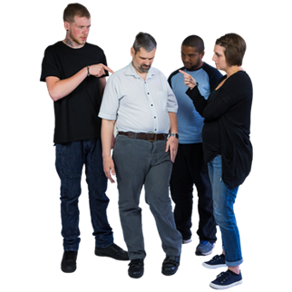 | Bullying is when someone or a group of people are mean to you on purpose.  This could be more than one time.
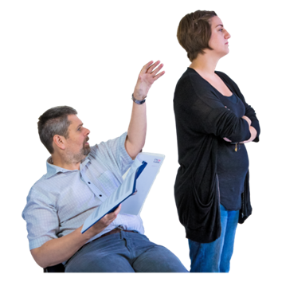 | Neglect is when someone who is supposed to be supporting you does not give you the care you need.
Contact the National Counselling and Referral Service if you need support after you have experienced
- Abuse

- Bullying

- Neglect

You can call the service on
1800 421 468.

Speak Up and be Safe from Abuse has Easy Read information.

This information can support you to communicate to someone that you
- Have experienced

- Or are still experiencing abuse

For more information visit
https://www.speakupandbe safe.com.au/
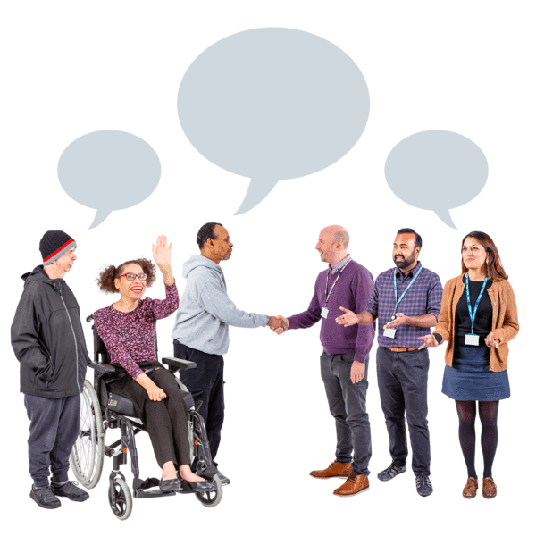 | The Royal Commission into Violence, Abuse, Neglect and Exploitation of People with Disabilities is a group of people who  - Listen to the stories of people with disability  - Tell the government how to make things better
You can let the Royal Commission know about your stories.

For more information visit https://disability.royalcommission. gov.au/share-your-story

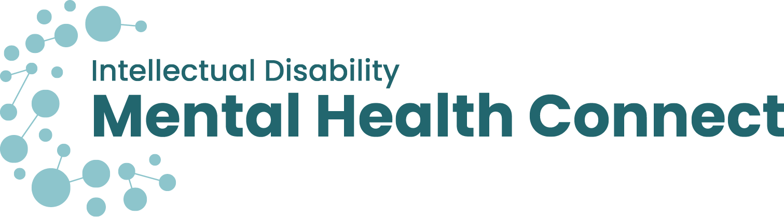

Supports for various groups
Authors
Janelle Weise, Claire Eagleson, Jenna Zhao, Tahli Hind, Dominique Abagi and Julian Trollor.

Department of Developmental Disability Neuropsychiatry, Discipline of Psychiatry and Mental Health, Faculty of Medicine & Health, UNSW Sydney

The information in this Easy Read sheet is from the https://idmhconnect.health/ website. The website has resources that support people with intellectual disability to get the right services and support for their mental health.

For information on how to support people to use Easy Read visit https://www.3dn.unsw.edu.au/professionals_toolkit

© Department of Developmental Disability Neuropsychiatry UNSW Sydney 16.03.22 v1
No changes can be made without author consent.
