I am not feeling better
 | This information is about when you might not be feeling better and what you can do.  It has information on | Page
 | - You can make an appointment with your GP or mental health worker | 2
 | - If you are in hospital for your mental health | 7
 | - Change in level of care | 10
You can make an appointment with your GP or mental health worker
 | If your treatment does not help you feel better let your GP or mental health worker know.
 | A GP is the doctor that you see when you  - Are sick  - Need a health check
 | Mental health workers are people who work to help you with your mental health.
 | Mental health is about  - How you think  - How you feel
 | Before you communicate with your GP or mental health worker you can make a list of things you want to let them know.
 | To communicate is how you understand and share your feelings or information.
 | You can make a list of questions.
 | You can also make a list of any side effects from your medication.  A side effect is an unpleasant effect of medication on your body or thinking.  A side effect can make you feel unwell.

 | Medication is sometimes called medicine or drugs.  Medication can be in  - A tablet  - A pill  - A drink  - An injection
 | If you have side effects your mental health worker might tell you to change  - How much medication you take
 | - The type of medication you take
 | You can find out more about medication online.  Visit https://cid.org.au/resource/me-and-my-medication-guide/
 | There are also lots of factsheets on different medications.  For more information visit  https://www.birmingham.ac.uk/research/activity/ld-medication-guide/downloads/medicine-information.aspx
 | You may like to ask someone you trust or your doctor to look at these with you.  There are many people you might trust.  For more information about who you might trust visit https://www.idmhconnect.health/  someone-trust
 | Your mental health worker might change your treatment.  They might try a new treatment.
 | Treatments are things that can help you feel better.  Treatments can be  - Medication  - Therapies
 | Therapies are activities your mental health workers use to support your mental health.

If you are in hospital for your mental health
 | If you are in hospital for your mental health communicate with your doctor about your treatment.
 | If you are in hospital for your mental health you could be  - A voluntary patient  - An involuntary patient
 | Voluntary patient  You are a voluntary patient if you decide to go to hospital for mental health treatment.
 | If you are a voluntary patient you or your guardian can  - Choose what type of treatment you want  - Ask to have a different treatment  - Ask to stop treatment
 | A guardian is a person who helps you make decisions about parts of your life when you cannot make decisions by yourself.
 | Involuntary patient  If you are an involuntary patient you must stay in hospital for mental health treatment until you are well enough to go home.  It is not your choice when you leave.
You can let your doctor know if you

- Think your treatment is not working

- Would like another type of treatment

But your doctor will decide what the best treatment is for you.
 | If you are an involuntary patient you can be given treatment even if you do not want it.  You must still be told what the treatment is.
 | Your doctor will try to give you the treatment you want  They will help you choose the best treatment to help you get well.
Change in level of care
 | If your current care plan is not working you might need a different level of care.
 | A care plan is a list of things you can do to help you get better.  A care plan is sometimes called a treatment plan.  Below are some examples of a change in level of care.
 | You might see your GP for medication and not feel better.  Your GP might then decide you should see a psychiatrist.
 | A psychiatrist is a doctor who helps you with your mental health.  A psychiatrist knows a lot about medication for mental health.
 | Your psychiatrist can also ask a specialised intellectual disability mental health service to support you.
 | Specialised intellectual disability mental health services know a lot about helping people with intellectual disability.
 | Your psychiatrist might suggest you should go to hospital if  - Your treatment is not working  - You feel very mentally unwell
 | In hospital you can be looked after until the doctors find a treatment that works for you.
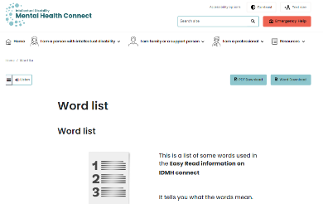 | There are some tricky words in this Easy Read sheet.  For more information about these words go to  https://www.idmhconnect.health/word-list


 | Who wrote this Easy Read  Janelle Weise, Claire Eagleson, Jenna Zhao, Tahli Hind, Dominique Abagi and Julian Trollor.
 | Where these people work  Department of Developmental Disability Neuropsychiatry UNSW Sydney.  Also known as 3DN.  For more information about who wrote this Easy Read go to https://idmhconnect.health/who-wrote-easy-read
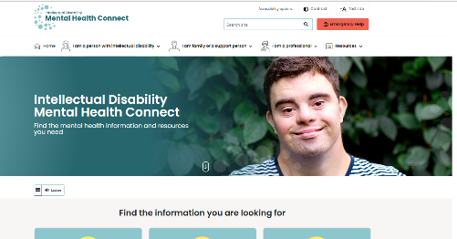   | The Council for Intellectual Disability reviewed this Easy Read sheet.  The information in this Easy Read sheet is from the https://idmhconnect.health/ website
 | For information on how to support people to use Easy Read go to https://www.3dn.unsw.edu.au/ professionals_toolkit  © Department of Developmental Disability Neuropsychiatry UNSW Sydney 27.01.2023 v2  No changes can be made without asking the people who wrote this sheet.

