Emergency Help
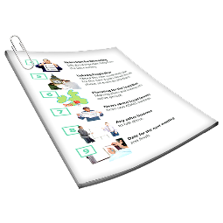 | This information is about how to get emergency help in a crisis.  A crisis is when you are in danger or are very upset.
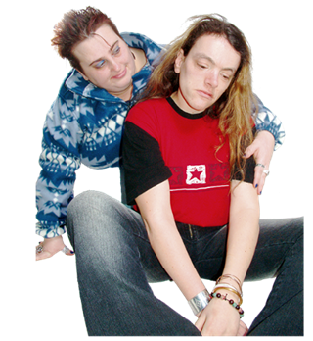 | You might be in danger if  - You want to hurt yourself  - You want to hurt someone else  - You want to die

If you or someone else is in danger and need help now
 | Call 000 for an ambulance or the police.
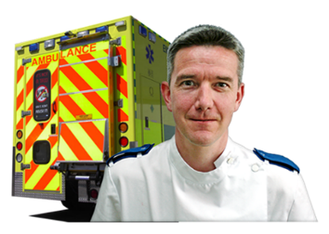 | Or go to an emergency department at a hospital.
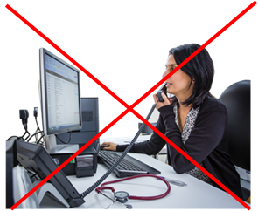 | You do not need an appointment to go to an emergency department.
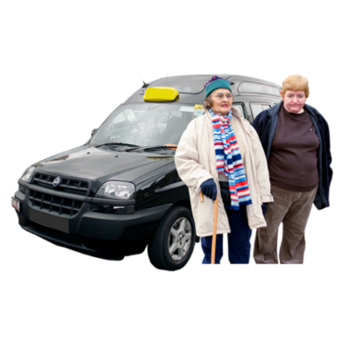 | You can ask someone you trust to take you to the emergency department.
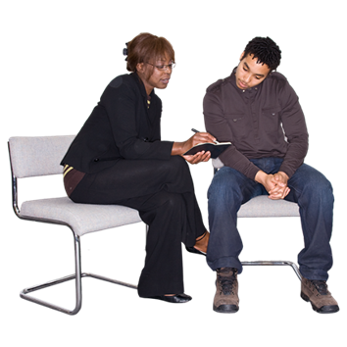 | There are many people you might trust.  For more information about who you might trust go to https://www.idmhconnect.health/  someone-trust

If you are very upset and need to speak to someone now you can
 | Communicate with someone you trust.
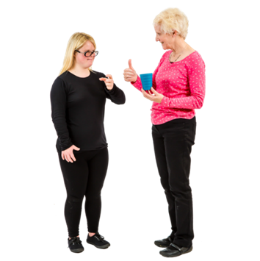 | To communicate is how you understand and share your feelings or information.
 | You can also communicate with services by  - Phone  - Online
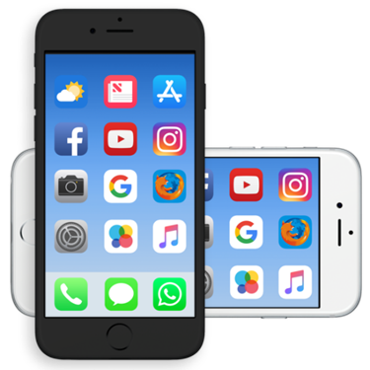 | Lifeline Australia  Call on 13 11 14 any time of the day.  Text 0477 13 11 14 12 from 12 noon to 6am  Chat online on https://www.lifeline.org.au/crisis-chat/ from 12 noon to 6 am

 | NSW Mental Health Line  If you need to speak with a mental health worker you can ring the NSW Mental Health Line on 1800 011 511 any time on any day.
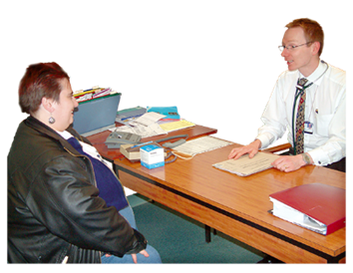 | Mental health workers are people who work to help you with your mental health.
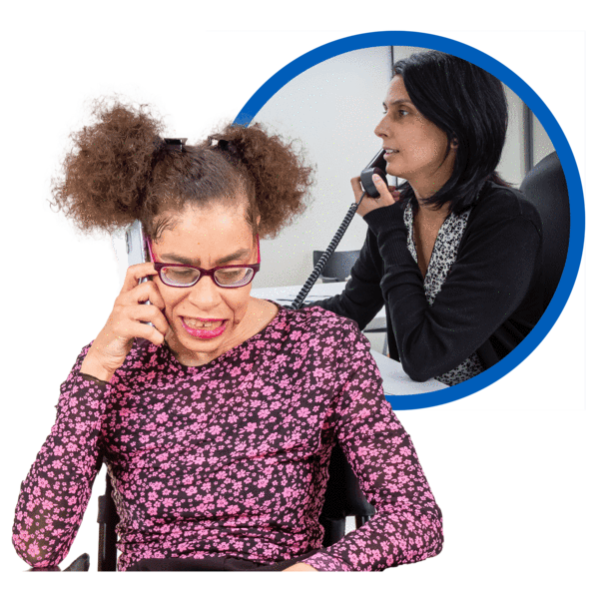 | The mental health worker might  - Refer you to the local mental health team  - Give you information about other services that can help you
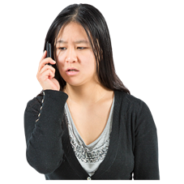 | Suicide Call Back Service  Call on 1300 659 467
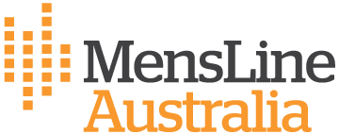 | MensLine Australia  Call on 1300 78 99 78
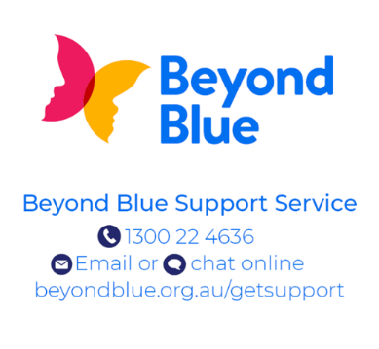 | Beyond Blue  Call on 1300 22 4636

You can also get support from your
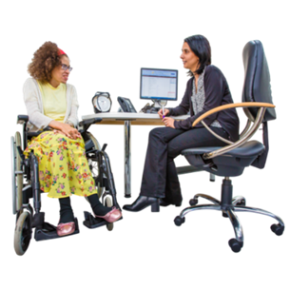 | GP  A GP is the doctor that you see when you  - Are sick  - Need a health check
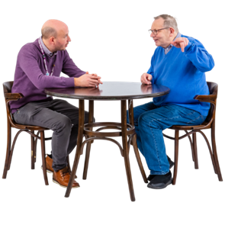 | Psychologist  If you have one.  A psychologist helps you with your mental health by talking with you.  Psychologists help you find things you can do to feel better.
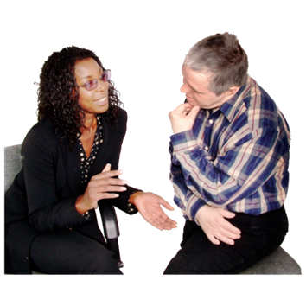 | Psychiatrist  If you have one.  A psychiatrist is a doctor who helps you with your mental health using talking and medicine.
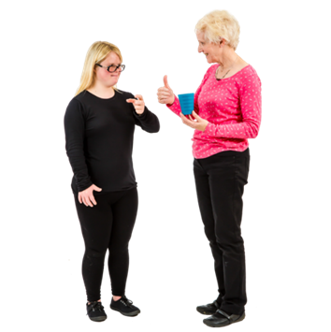 | They might not be able to communicate with you right away.  But they will be able to help you.

Emergency help card
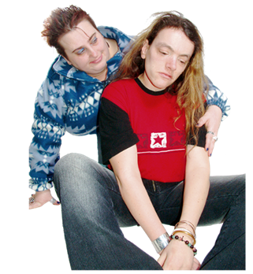 | An Emergency help card can keep you and others safe in a crisis.
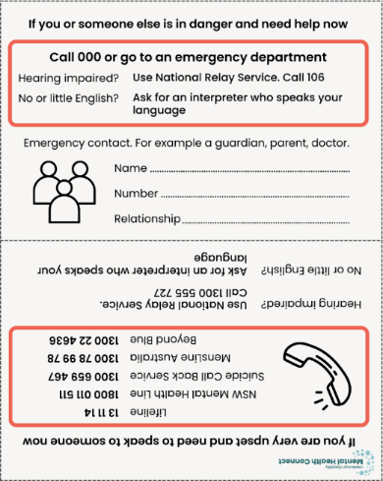 | It can support you and others to  - Know what to do in a crisis  - Know who to contact in a crisis  - Call phone lines that can support you in a crisis
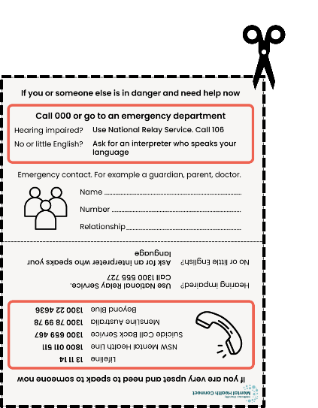 | You can use the Emergency help card template to make an Emergency Card that is right for you.
 | For more information about the Emergency help card go to https://idmhconnect.health/emergency-help-template/ER



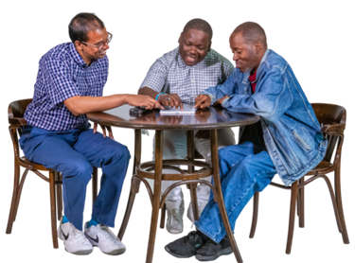 | Who wrote this Easy Read  Janelle Weise, Claire Eagleson, Jenna Zhao, Tahli Hind, Dominique Abagi and Julian Trollor.  Where these people work
 | Department of Developmental Disability Neuropsychiatry UNSW Sydney.  Also known as 3DN.  For more information about who wrote this Easy Read go to https://idmhconnect.health/who-wrote-easy-read
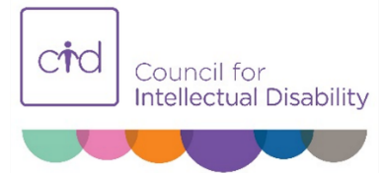  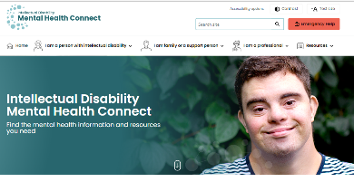 | The Council for Intellectual Disability reviewed this Easy Read sheet.  The information in this Easy Read sheet is from the https://idmhconnect.health/ website
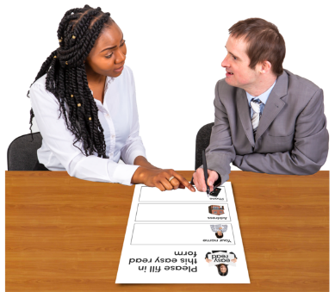 | For information on how to support people to use Easy Read go to https://www.3dn.unsw.edu.au/ professionals_toolkit  © Department of Developmental Disability Neuropsychiatry UNSW Sydney 20.02.22 v2  No changes can be made without asking the people who wrote this sheet.

