Communicating about my mental health
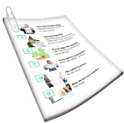 | This information is about communicating about your mental health.  It has information about | Page
 | - Communicating about your mental health | 3
 | - Why communicating about your mental health is important | 6
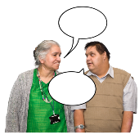 | - The best way to communicate about your mental health | 7
 | - How you can let health workers know how you like to communicate | 12
 | - How you can use tools to help you communicate about your mental health | 15

Communicating about your mental health
There are many ways to communicate about mental health.

To communicate is how you understand and share your feelings or information.
Mental health is about

- How you think

- How you feel
You may want to communicate about your mental health to someone you trust.

There are many people you might trust.

For more information about who you might trust go to https://www.idmhconnect.health/
someone-trust

Below are examples of things you might want to communicate about to someone.

- Your feelings
- When you feel different to normal

For example if you are sad more often than usual.
- You notice a change in your activities

For example if you do not feel like seeing people you usually visit.
- If your daily tasks are becoming more difficult

For example if you find it harder to clean your house.
- Why you feel the way you do
- What might make you feel better
It is OK if you do not want to share everything.

Only tell someone things you are comfortable sharing.

Why communicating about your mental health is important
. | Communicating with others about your mental health can help you
 | - Feel better
 | - Get help if you need it
The best way to communicate about your mental health

It is OK if you do not know

- How you feel

- Why you feel this way

You could just tell the person you feel different to normal.

What you can do if you do not know how to communicate about your mental health

You may feel you need help with your mental health.
 | Below are some examples of ways you could communicate or ask someone you trust for support.
You could communicate

- I feel different to normal

- I need some help

- I would like to talk about how I am feeling
- I feel sad

- I feel down
 | - I feel worried
 | - I feel scared
 | - I feel angry
- Something has happened to me

- I am worried

 | - I have noticed changes in my life
For example

- I have trouble getting out of bed

 | - I do not feel like eating
 | - I do not want to see my friends
 | You do not have to communicate with someone if you do not want to.
 | Some people are not sure how to support someone with their mental health.
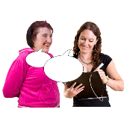 | If the person you ask for support does not know how to help  - Try talking to another person you trust  - Ask them to find someone who can help
For more information about where to get help for your mental health go to https://www.idmhconnect.health/
where-start-get-help/ER

Let health workers know how you like to communicate
It is good to let health workers know how you like to communicate.

This may be a doctor such as your GP or a mental health worker.
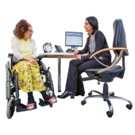 | A GP is the doctor that you see when you  - Are sick  - Need a health check
 | Mental health workers are people who work to help you with your mental health.
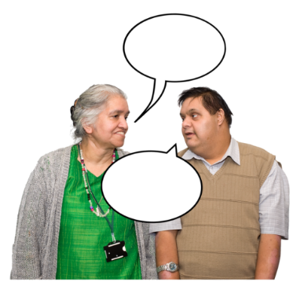 | Knowing how you communicate will help  - Them to understand you better  - You to understand them better
You can let health workers know how you would like to communicate

- When you make an appointment

- At your first appointment
 | You can ask someone you trust to help explain how you like to communicate.
You could also include the information in a health passport.

A health passport is a list of important information about you and your health.
 | For example you could use the Council for Intellectual Disability’s My Health Matters folder.
 | For more information about the My Health Matters folder go to https://cid.org.au/resource/my-health-matters-folder/

How you can use tools to help you communicate about your mental health
Some people use communication tools to help them share information.

Below are some examples of communication tools.
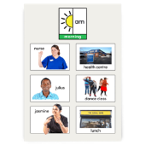 | - Written text  - Pictures  - Symbols
- Body Movements

- Pointing

- Sign language
You can use communication tools to show others how you feel.

You can share when you

- Feel good

- Do not feel good

 | Below are some examples of common communication tools you can use to show someone how you feel.
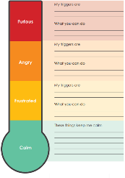 | Feelings thermometer  Different feelings can change  - How we think  - How our bodies feel  - What we do
A feelings thermometer can help you

- Notice your feelings

- Choose what to do when you feel this way
A feelings thermometer has

- A colour for each feeling

- A picture for each feeling

- Some ideas on what you can do when you do not feel good
 | For example if your feelings are in the green area this shows you feel good.
 | Or if your feelings are in the red area this shows you do not feel good.
It is OK not to feel good sometimes.

We can try to change what we do to help us feel better.

You can make a feelings thermometer right for you using the Council of Intellectual Disability feelings thermometer.

For more information visit page 30 of their My Health Matters Folder https://cid.org.au/resource/my-health-matters-folder/

Feelings diary

A diary is a place where you keep information.

A feelings diary is a place where you can note down your thoughts and feelings.
You might note down your thoughts and feelings in writing.

You might note them down in a drawing.

 | You might also note them down with a photo or video.
Your feelings diary can be on

- Paper
 | - Your phone
 | - Your computer
 | Below are some examples of things you might want to note down in your feelings diary
 | - Something that happened
- How it made you feel

- How strong the feeling was
Other examples of things you might want to note down in your feelings diary are

- How your body felt
 | - If you might have done anything differently
You can share your feelings diary with someone you trust.

It is OK if you do not want to share your feelings diary.

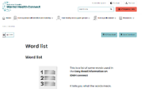 | There are some tricky words in this Easy Read sheet.  For more information about these words go to  https://www.idmhconnect.health/word-list

Who wrote this Easy Read

Janelle Weise, Claire Eagleson, Jenna Zhao, Tahli Hind, Dominique Abagi and Julian Trollor.

Where these people work
Department of Developmental Disability Neuropsychiatry UNSW Sydney.

Also known as 3DN.

For more information about who wrote this Easy Read go to https://idmhconnect.health/who-wrote-easy-read
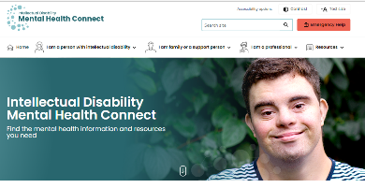 | The Council for Intellectual Disability reviewed this Easy Read sheet.  The information in this Easy Read sheet is from the https://idmhconnect.health/ website
For information on how to support people to use Easy Read go to https://www.3dn.unsw.edu.au/ professionals_toolkit

© Department of Developmental Disability Neuropsychiatry UNSW Sydney 27.012023 v2

No changes can be made without asking the people who wrote this sheet.

