About mental health
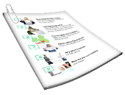 | This information is about mental health.  It has information on | Page
 | - What mental health is | 3
 | - What good mental health is | 5
 | - What a mental health problem is | 8
 | - What can lead to mental health problems and mental illness | 13
 | - What is not a mental health problem | 15
 | - Mental health and intellectual disability | 16

What mental health is
Mental health is about
- How you think

- How you feel
You have different types of feelings.

You can spot different feelings by noticing

- Changes in how you think

- Changes in how your body feels
Feelings can make you feel good.

You can be

- Happy

- Calm
Feelings can make you feel bad.

You can be

- Upset

- Sad

- Worried

What good mental health is
Good mental health can mean different things.

Good mental health is when you feel OK about having different kinds of feelings.

Good mental health is being able to do everyday things like making breakfast.
Good mental health is having people you enjoy spending time with.
Good mental health is when you do things you like.
To have good mental health you need to take care of different parts of your life.
Below are some examples of some ways you can take care of these different parts.

- A safe place to live
- Healthy food
- Time to relax
Some other examples of some ways you can take care of these different parts are

- Exercise
- Enough sleep
- Time with family and friends

- Time to do things you enjoy
What a mental health problem is
There are different words used to talk about mental health.

A mental health problem is when your feelings start to worry you.
It can be when you cannot control your feelings.

You might not be able to calm your feelings to think clearly.

You might feel different to the way you usually do.
A mental illness is when your feelings and thoughts make it hard to do things.

Sometimes mental illness is also called a mental disorder.
A serious mental illness is when your feelings and thoughts make you feel so bad that you cannot do things.
Below are some names for mental health problems and mental illness.

Anxiety is when people feel worried about what is going to happen in the future.
Depression is when people
- Feel very sad or down for a long time

- Might not feel like doing the things you usually do
Bipolar disorder is when people feel very down sometimes and have lots of energy at other times.
Psychosis is when people might find it hard to tell what is real.

People with psychosis might

- Hear voices when no one is there
- See things that are not there
People with psychosis might

- Believe things that are not true
Schizophrenia is a type of psychosis.

For more information about types of mental health problems and mental illness go to
https://www.beyondblue.org.au/
the-facts
The NDIS might be able to help people who need support because they have a mental health problem.

NDIS is short for National Disability Insurance Scheme.

The NDIS calls disabilities that happen because of mental illness a psychosocial disability.
For more information about what support you can get from the NDIS discuss with your support coordinator.
A support coordinator is a person who helps plan and organise

- Your care

- Other services you will get
If you think you may have a mental health problem or mental illness, go to

- When to get help https://www.idmhconnect.health/when-get-help/ER

- Where to start to get help https://www.idmhconnect.health/where-start-get-help/ER

What can lead to mental health problems and mental illness
There are a lot of reasons someone can have mental health problems.

These include
- Feeling stressed for a long time
- A family member who has a mental health problem
- Health issues
- Not enough support
- Money problems
- Not doing enough exercise
- Eating unhealthy food and drinks
- Using drugs and drinking alcohol
What is not a mental health problem
Not all feelings that make you feel bad are a mental health problem.

Everyone has these feelings sometimes.

They usually do not last long.
You might have a mental health problem or mental illness if

- You feel bad for 2 weeks or more
- The feelings that make you feel bad keep coming back

Mental health and intellectual disability
 | A lot of people with intellectual disability have mental health problems or mental illness.
This does not mean that you will have mental health problems or mental illness.

Every person is different.

 | It is important to know about mental illness so you can get help early.
 | There are things you can do to have good mental health.
For more information on what you can do to have good mental health go to https://www.idmhconnect.health/
tips-good-mental-health/ER

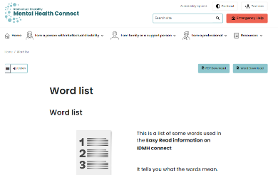 | There are some tricky words in this Easy Read sheet.  For more information about these words go to  https://www.idmhconnect.health/word-list

Who wrote this Easy Read

Janelle Weise, Claire Eagleson, Jenna Zhao, Tahli Hind, Dominique Abagi and Julian Trollor.

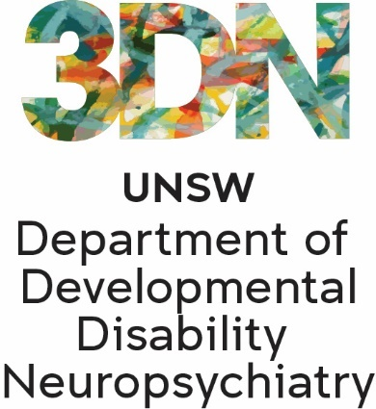 | Where these people work  Department of Developmental Disability Neuropsychiatry UNSW Sydney.  Also known as 3DN.  For more information about who wrote this Easy Read go to https://idmhconnect.health/who-wrote-easy-read
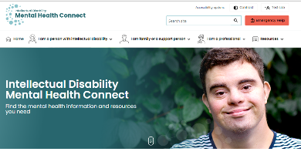 | The Council for Intellectual Disability reviewed this Easy Read sheet.  The information in this Easy Read sheet is from the https://idmhconnect.health/ website
For information on how to support people to use Easy Read go to https://www.3dn.unsw.edu.au/ professionals_toolkit

© Department of Developmental Disability Neuropsychiatry UNSW Sydney 27.01.2023 v2

No changes can be made without asking the people who wrote this sheet.

